Bushra Hameed

Addition Tower

The addition tower is a pyramid made up of seven levels. The base level consists of seven cells. Within the game, there are cells labeled with a variable whose integer value must be solved by the user. In order to obtain the value of the variable, the sum of two consecutive numbers add up to the cell directly above the two.

The Game:

1. Click “Run”, “Assemble”, and click on the green play button to run the game
2. 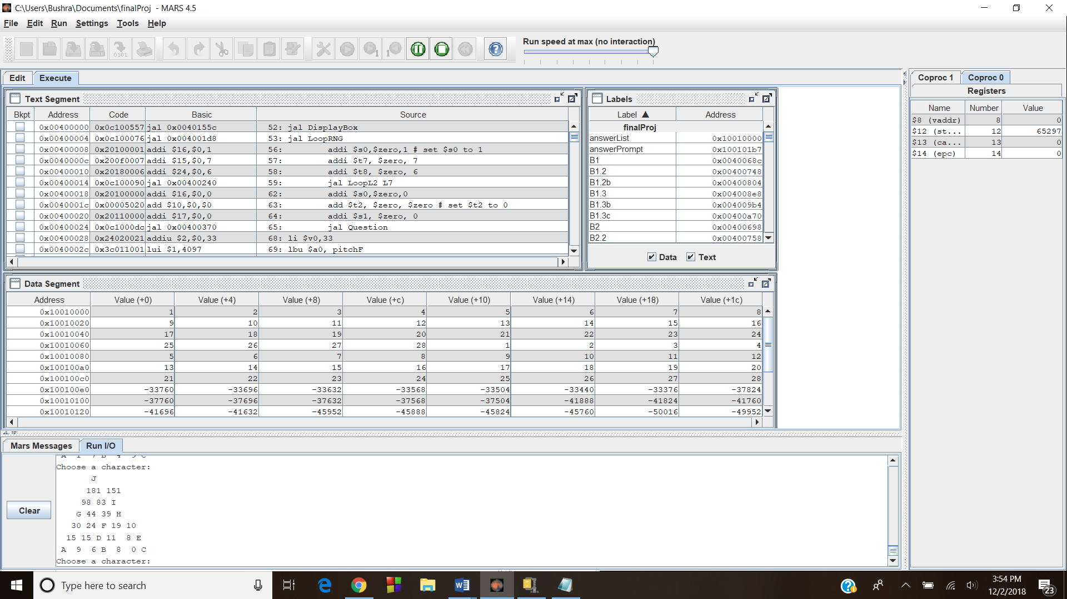The addition tower is displayed:
3. The user must begin by entering the letter they wish to solve
4. The user is then prompted to enter the value of the variable
5. If the integer value of the variable is correct, a tone indicating the user’s success is played
6. If the integer value of the variable is incorrect, a differing tone is played followed by the chance to try again
7. The game is complete once the user determines the integer values of all of the letters

Bitmap Display:

1. Run and assemble the program
2. 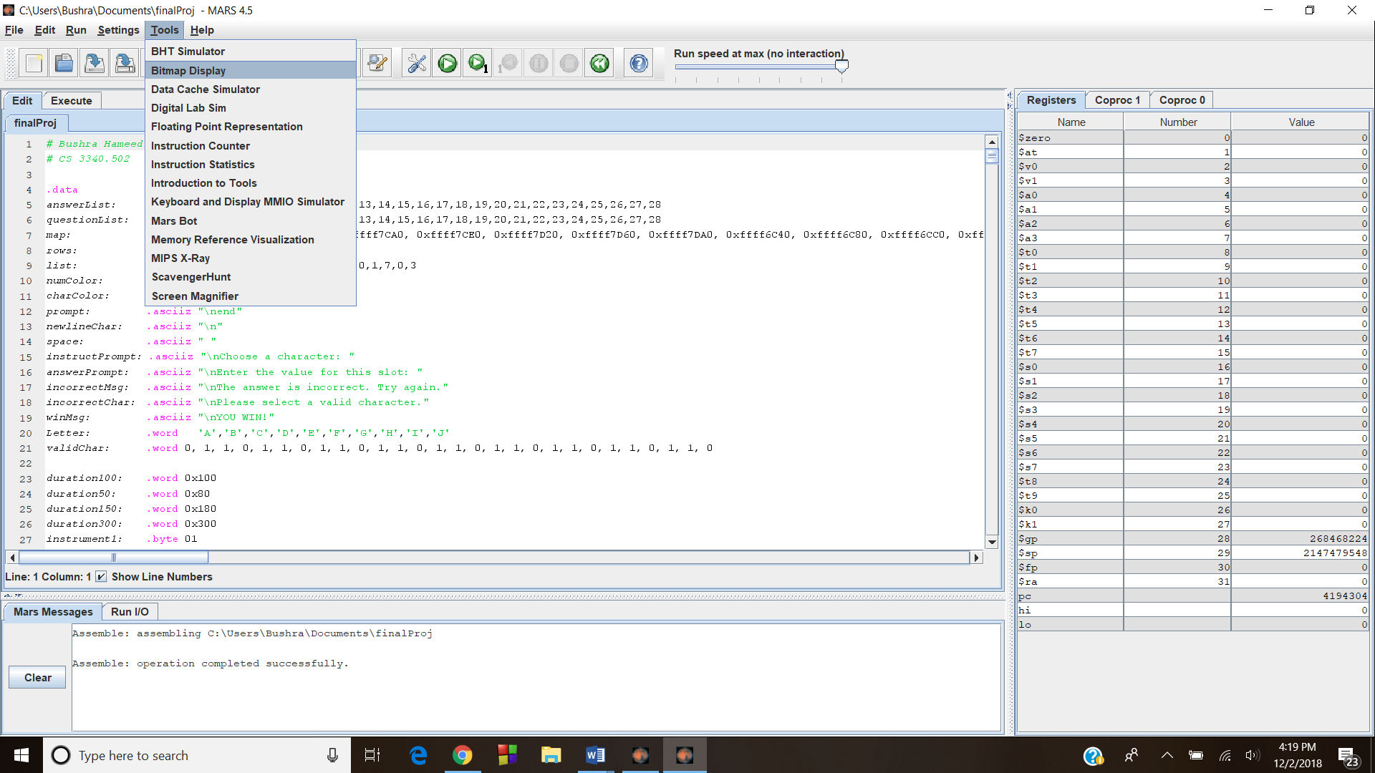Select ‘Tools’ followed by ‘Bitmap Display’
3. Change the ‘Unit Width in Pixels’ and ‘Unit Height in Pixels’ to 4
4. Change ‘Base address for display’ to ‘0xffff000’
5. 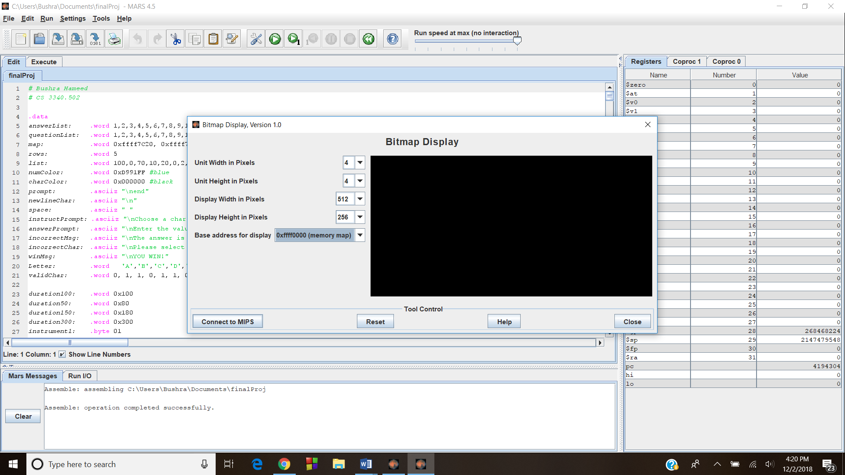Select ‘Connect to MIPS’
6. 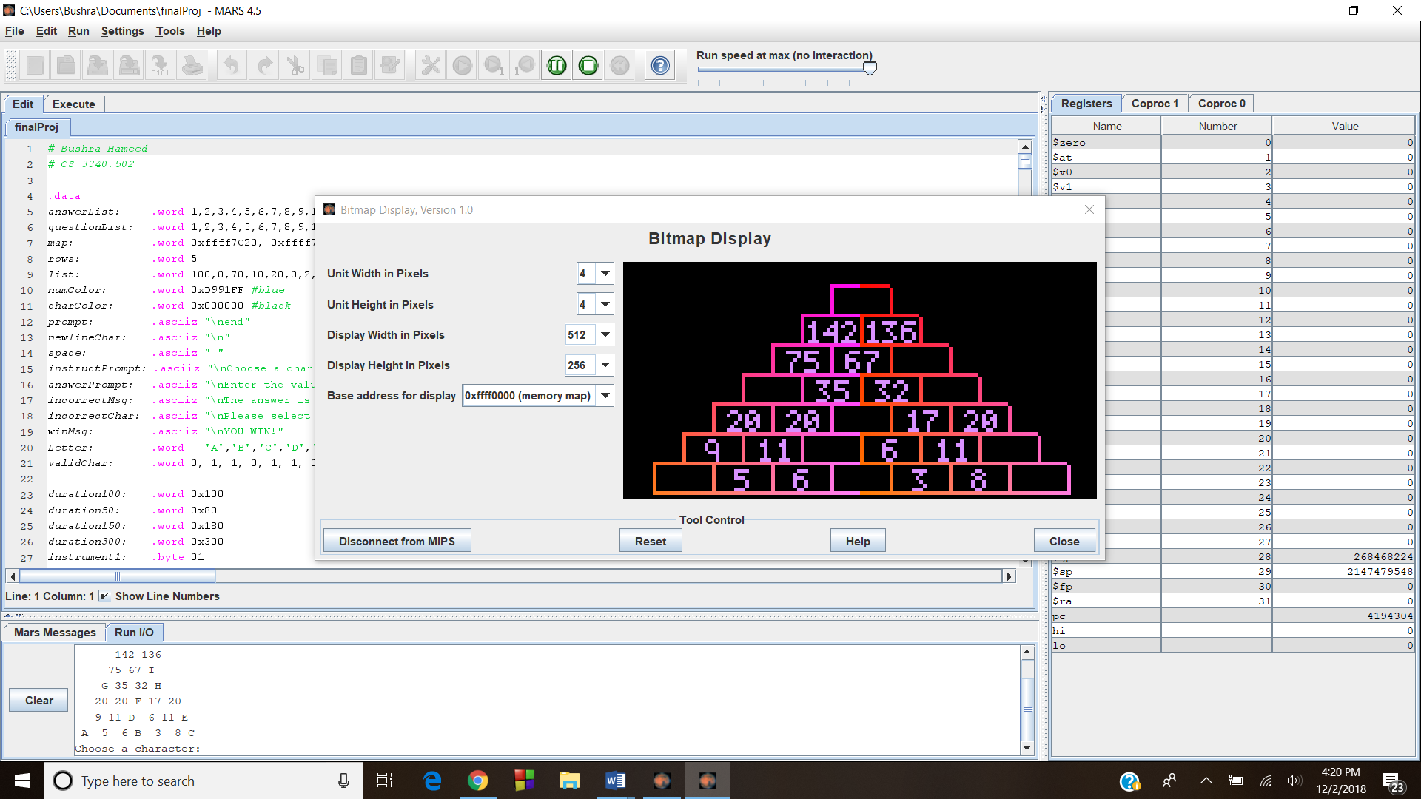Run the program and enter the values